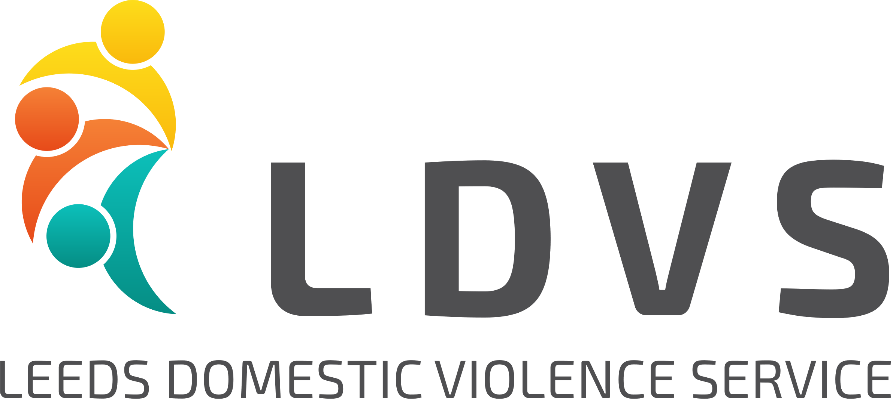
Leeds Domestic Violence Service – Privacy Notice

Leeds Domestic Violence Service (LDVS) is a partnership between Leeds Women’s Aid (LWA), Behind Closed Doors (BCD) and Women’s Health Matters (WHM).

LDVS is committed to protecting your privacy, whether as a member of staff, client, stakeholder, supporter, supplier or visitor to our website. This Privacy Notice explains what personal data we may collect, how we use it and how we ensure it is kept secure.

The 3 partners are the Data Controllers for all the personal data which LDVS collects for various reasons and this is held electronically on the computer, in paper files, and/or on locked and protected mobile devices. We take collective responsibility to ensure that data is controlled appropriately and that all the individuals that process data on our behalf are trained and appropriate. All personal data which we collect will be used and protected in accordance with our Data Protection policy statement. We are responsible for complying with data protection legislation including the General Data Protection Regulation (GDPR) and Data Protection Act (DPA) 2018.

What is Personal Data?
Personal data is any information which relates to and identifies a living person; for example, name, address, bank details, CCTV images, computer IP address, email address.

Some types of personal information are classified as ‘sensitive personal data’ and this includes ethnicity; religious beliefs, physical/mental health; sexuality, information about criminal offences or proceedings.

Any organisation which processes personal data must have a lawful basis for doing so. LWA uses various legal bases for processing personal data and these are recorded in the section ‘What Information does LDVS collect and why’.

How LDVS collects information
LDVS may collect personal information in the following ways:

- Directly from you – if you refer yourself for support or make a donation to us
- From other organisations, with your consent – for example if the police or other agency makes a referral to us for support on your behalf
- Publicly available information – we may use data freely available to the public, such as within the criminal courts system or published in articles

What information does LDVS collect and why?
LDVS needs to collect personal data in order to fulfil its role to provide support to victims of domestic abuse and to meet our obligations as members of various statutory review panels, such as the Multi Agency Risk Assessment Conference (MARAC).

Some information is collected because it is in our legitimate interest to process the data and in this situation we always balance this against your rights as an individual. We ensure that we only use personal data for a purpose that you would reasonably expect. Other data will be collected with the consent of the individual concerned.

Detailed below are the types of personal data which we collect and the reasons, or legal basis, for doing so:

- Data relating to people who are referred to our services for support are collected to enable us to make safe contact with them. The consent of the individual being referred should always be obtained by the referring agency. LDVS has a legitimate interest in processing names, addresses, contact details and demographic/health information if this is available, in order to make contact to offer support.
- Individuals who accept support from LDVS, may be asked for further information in order to provide the best possible support to them. This may include demographic information, details of their children, emergency contact details, health information. This information may also be used for equalities monitoring and in this situation, all data will be anonymised. Consent will always be asked when collecting this information.
- Personal data of high risk MARAC cases will be recorded on our system. Processing of this data is required in order for LDVS to fulfil its official function as MARAC partner.

Some anonymised data will be used for monitoring and reporting purposes. No individuals will be identifiable from data used for this purpose.

Is my data secure with LDVS?
In short, yes it is. Personal data may be stored on computer, in paper files, and/or on locked and protected mobile devices. We make sure that all personal data is held in a secure way and only relevant and appropriate people will be able to access it. Detailed below are some examples of how we keep information secure:
- Access to personal data on case management systems is restricted on a ‘need to know’ basis. Appropriate permission levels are applied so only relevant staff have access to data.
- Data stored electronically will be password protected and only appropriate staff will have access.
- All staff are fully trained in how to handle personal data including when and how it can be shared.
- LDVS systems have full IT security protection, including firewalls and encryption.

All personal data held by LDVS is stored on systems in the UK. No data is held or stored outside the UK.
Personal data will be retained by LDVS for a minimum period of time in accordance with applicable legislation. Data which is no longer required will be securely deleted and disposed of.

Who does LDVS share information with?
LDVS uses various other organisations to help deliver support and to assist with our legal obligations by processing data on our behalf. The 3 partners delivering LDVS services are known as Data Controllers. We have agreements about the types of data we hold and share to be able to offer services. LWA is the lead partner, and responsible to the funder, therefore LWA has an agreement with all partners to ensure that they are compliant with data protection legislation. We also work with other companies who process data on our behalf, these companies are known as Data Processors. Your data may be shared with all or some of these organisations and it will only be shared if it is necessary to meet our obligations. For example, individuals who are referred for support will have their details added to a case management system.

When LDVS shares personal information with another organisation will always have an agreement in place to ensure that they comply with all data protection law.

In the course of providing support to clients, LDVS may also ask for consent to share personal data with other organisations so that we can provide the best support to you. For example, this could include housing providers, health agencies, education or any other relevant agencies. This will be explained to you at the start of support and you can give or withdraw your consent to share data with other agencies at any time.

On a rare occasion it may be necessary for us to share personal information without consent if we are required to do so by a court order or if there are other valid reasons, such as the protect a child or adult who is thought to be at risk or to stop a crime. If this happens, then we will record our reasons for doing it, the information we have shared. We will also let you know what we have done, if it is safe to do so.

We never sell your personal information on to anyone else.

It’s your personal data
The data we hold is about you and the law gives you rights about what we can do with your information:

- Consent
You can give or withdraw consent for LDVS to share your personal data at any time. This will be explained to you at the start of support. There may be circumstances in which we override your consent, but reasons for this will be always explained to you.

- Right of Access
You can ask for copies of the information we hold about you and this is called a ‘Subject Access Request’. These requests can be in writing or verbally. If you ask to see your data, we will provide your information within one month of receipt of the request.

- Inaccurate or incomplete information
If you think that any of the data we hold is wrong or missing, please let us know.

- Right to be forgotten
It is possible to ask for all your personal information to be deleted from LDVS records. There may be some reasons why we are unable to delete all your personal information, for example, if we are required to keep it by law.
- Right to object to processing
You have the right to object to the processing of your personal information in certain circumstances

If you wish to exercise any of the above rights, please contact us in one of the following ways:

Email: hello@ldvs.uk
Phone: 0113 246 0401
Via the Contact Us form on our website: https://ldvs.uk/contact/

More information is available about your rights on the ICO website:

https://ico.org.uk/your-data-matters/

Cookies and our website
Cookies are small text files that are placed on your computer by websites that you visit. They are widely used in order to make websites work, or work more efficiently, as well as to provide information to the owners of the site.

We use traffic log cookies to identify which pages on the website are being used. This helps us analyse data about web page traffic and improve our website and we need to use it for statistical analytical purposes and then the data is removed from the system.

Most web browsers allow some control of most cookies and this is done through the internet browser settings. To find out more about cookies, visit www.aboutcookies.org or www.allaboutcookies.org.

Our website may contain links to other websites which may be of use to you. This privacy notice only applies to this website so when you link to another website, you should also read their own privacy notices.

How to contact us
If you have any concerns or worries about how your personal data is being processed by us, please contact us via email to:
hello@ldvs.uk

or by writing to us at the following address:

Data Protection Enquiry
LDVS
PO Box 826
LEEDS
LS1 9PL

Further information about privacy and personal data
If you would like to get independent advice about data protection, data sharing issues or privacy, or lodge a complaint about how we process your data, you can contact the Information Commissioner’s Office (ICO):

Information Commissioner's Office
Wycliffe House
Water Lane
Wilmslow
Cheshire
SK9 5AF

Tel: 0303 123 1113

ICO Website: https://ico.org.uk/global/contact-us/

Date approved: October 2021
Review Date: October 2023

